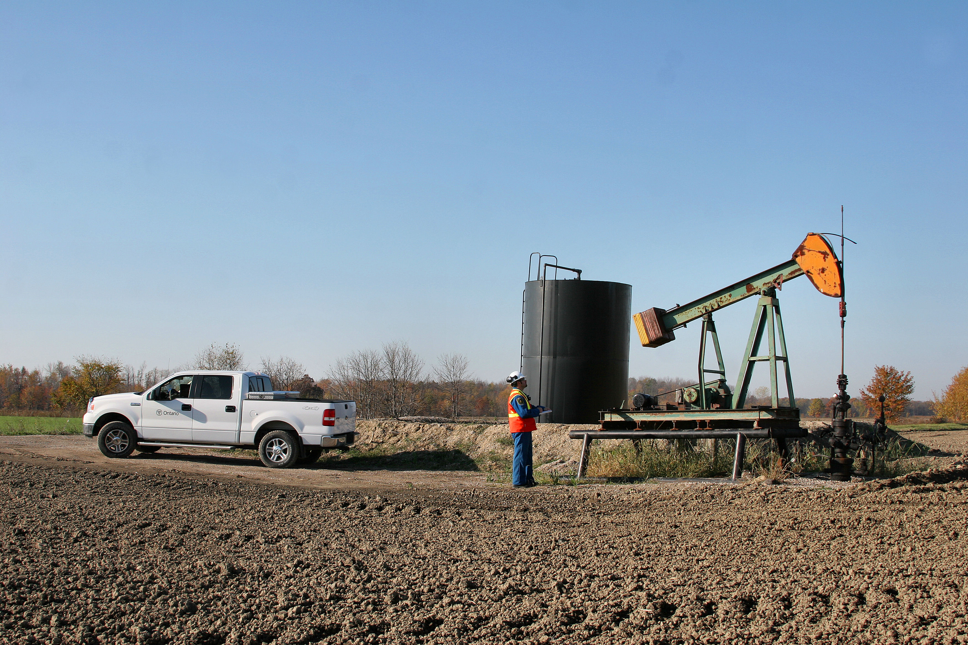

Petroleum Well
User Guide

Petroleum Operations Section,
Integration Branch

Drafted: May 21, 2014
Disclaimer
This technical documentation has been prepared by Her Majesty the Queen in right of Ontario as represented by the Ministry of Natural Resources (the “Ministry”). No warranties or representations, express or implied, statutory or otherwise shall apply or are being made by the Ministry with respect to the documentation, its accuracy or its completeness. In no event will the Ministry be liable or responsible for any lost profits, loss of revenue or earnings, claims by third parties or for any economic, indirect, special, incidental, consequential or exemplary damage resulting from any errors, inaccuracies or omissions in this documentation; and in no event will the Ministry’s liability for any such errors, inaccuracies or omissions on any particular claim, proceeding or action, exceed the actual consideration paid by the claimant involved to the Ministry for the materials to which this instructional documentation relates. Save and except for the liability expressly provided for above, the Ministry shall have no obligation, duty or liability whatsoever in contract, tort or otherwise, including any liability or negligence. The limitations, exclusions and disclaimers expressed above shall apply irrespective of the nature of any cause of action, demand or action, including but not limited to breach of contract, negligence, strict liability, tort or any other legal theory, and shall survive any fundamental breach or breaches.
For more information about this guide, please contact:
LIO Support, Email: lio@ontario.ca Phone: 705-755-1878
Please report any mistakes, omissions or website links that need updating. Recommendations and ideas to improve this document are welcome.

Table of Contents

1.0 Document Scope 4
2.0 MNR Petroleum Well GIS Mapping History 4
3.0 Oil, Gas and Salt Resources in Ontario 5
4.0 Petroleum Well (PETWELL) Data Class 7
4.1 Petroleum Well Attributes 8
4.1.1 Well Type Permissible Values 12
4.1.2 Well Mode Permissible Values 14
4.1.3 Metes and Bounds / Lot Boundary Coordinates 15
4.1.4 Offshore Tract Naming Convention 16
4.1.5 Well Direction Types 18
4.1.6 Petroleum Well Symbology Standard 20
4.2 Data Collection Guidelines 21
4.3 Data Maintenance Guidelines 22
4.4 General Data Access and Viewing 22
Appendix 1: Additional Resources 23
Appendix 2: Responsibilities of a LIO Data Class Information Owner 24
Appendix 3: Petroleum Well Data Maintenance 26
Appendix 4: Petroleum Well Data Models 27

Document Scope

This guide provides information about the Petroleum Well data class stored in the LIO Warehouse database. It will describe the context in which spatial and attribute data in these layers should be interpreted and used.
The confirmed Information Ownership (IO) for this layer falls under the responsibility of:

The Ontario Ministry of Natural Resources
Regional Operations Division
Integration Branch
Petroleum Operations Section

It is overseen by the Spatial Data Specialist in the Petroleum Operations Section. Information Owner responsibilities are summarized in Appendix 2 of this guide.

Data class maintenance is addressed in Section 3.0.

MNR Petroleum Well GIS Mapping History

The Ministry of Natural Resources (MNR) developed the initial Petroleum Well data set in the LIO Editor (then called NRVIS) and the LIO Warehouse in 1996. This layer was originally loaded with petroleum well locations gleaned from the now-defunct digital Ontario Base Map (OBM).
The data set underwent updates in 2005 to accommodate additional tables to capture borehole specific information. At this point, it became a LIO Warehouse only data class. In 2013, another review of the Petroleum Well data class was carried out to simplify the data class and remove tables no longer being used.

3.0 Oil, Gas and Salt Resources in Ontario
Oil, gas and salt resources can be found trapped underground in layers of ancient sedimentary rock which underlie all of southern Ontario, the Ottawa area, and large parts of Ontario’s far north.
Ontario’s oil, natural gas and salt resources are extracted by the drilling of wells. Since the beginning of the petroleum industry in Ontario in 1858, thousands of wells have been drilled. Crude oil and natural gas in Ontario has been discovered in commercial quantities in a total of over 300 separate "pools". Production from Ontario's crude oil and natural gas reservoirs accounts for approximately 1% of Ontario's annual domestic consumption of crude oil and 2% of Ontario's annual domestic consumption of natural gas. All of Ontario's crude oil and natural gas production is consumed within Ontario.
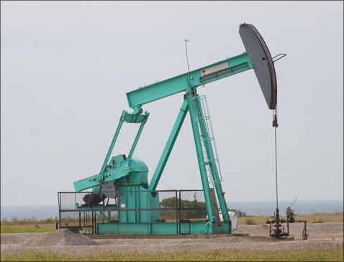
About 88,000 cubic meters of crude oil with a wellhead value of $50 million was produced in Ontario in 2009. This is enough to provide fuel for 40,000 cars annually.
It is estimated that there is 30 million cubic meters of remaining potential (undiscovered) resources of crude oil remaining in Ontario compared to 14.1 million cubic metres already produced. Most of the remaining undiscovered resources of crude oil lie on Crown lands under Lake Erie, Lake Huron, Lake St. Clair and Lake Ontario. It is estimated that the remaining undiscovered resources of natural gas in the province are approximately 35 billion cubic meters compared to cumulative production of 36.5 billion cubic metres to the end of 2009. This means, Ontario has potential natural gas resources equal to what has already been recovered over the years.
Figure 1 – Pump Jack on Oil Well
(Source: A. Castillo)
Salt deposits in Ontario are found in the Windsor and Sarnia-Goderich areas near the eastern edge of the Michigan Basin, and form an extension of the Michigan salt deposits. Two salt solution-mining sites located at Windsor and Goderich operate 19 salt solution mining wells. In 2006, salt solution-mining operations extracted approximately 300,000 tonnes of high-purity salt used for human consumption and for the production of sodium and chlorine-based chemicals. Underground mining of salt also occurs at these two sites.

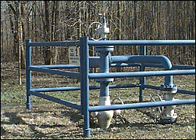
Wells can be used for temporary storage of hydrocarbons in subsurface geological formations. Natural gas storage facilities help to safeguard gas supplies and meet seasonal natural gas demands within the province. In summer when demand is low, natural gas is pumped into the underground storage facilities and withdrawn again in winter when demand is high. At peak times on very cold winter days, demand can be five or six times as high as on warm summer days. Underground storage of natural gas in depleted oil and gas reservoirs allows year-round supply to the province.
Figure 2 – Natural Gas and Storage Well (Source: A. Castillo)

Commercial reservoirs of oil and gas have been discovered in several different formations in the subsurface of southern Ontario, at depths varying from 100 to over 1100 metres. Natural gas is stored in depleted natural gas reservoirs. Liquefied hydrocarbons are stored in solution-mined caverns in thick underground salt bed.
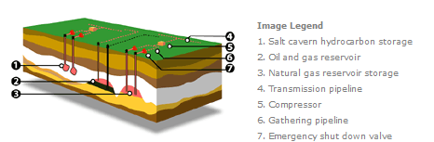
Figure 3 – Overview of Petroleum Well Operations (Source: MNR Website)

4.0 Petroleum Well (PETWELL) Data Class

This section describes the context and provides guidelines for the intended collection, use and maintenance of the information stored in the data class.
Petroleum Well data class Definition
A Petroleum Well is a point feature that identifies a well drilled into geological formations for: production of oil, gas or formation water (excluding fresh water); injection, storage and withdrawal of oil, gas, brine or other hydrocarbons; disposal of oil field fluid; mining of salt by the solution mining method; geological evaluation or testing of underground bedrock formations that may contain oil or gas.

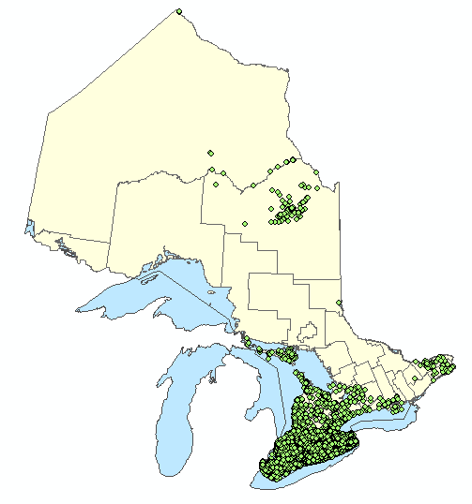
Petroleum Well is the official data class for identifying the location and attribute information of petroleum wells in Ontario. There are records of over 26,000 petroleum wells. The majority of the wells are located in southern Ontario including on the bed of Lake Erie, see Figure 4. The Petroleum Well data class is a point data set.
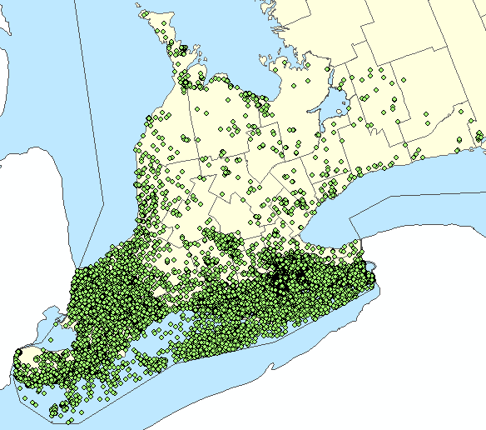

Figure 4 – Map of Petroleum Well data class point locations (Source: A. Castillo)

4.1 Petroleum Well Attributes
Disclaimer
Every possible effort has been made to ensure the accuracy of the information available. The petroleum wells data have been compiled from field survey data, old historical records, current paper documents, orthophotos and GPS collecting. The accuracy of the well location data varies from submetre to hundreds of metres, depending largely on the vintage of the data. Accuracy of wells information is not guaranteed. Users should verify critical information.
The following attributes are collected for Petroleum Well. For the logical and physical models please see Appendix 4.

Table Name: PETROLEUM_WELL_FT – this is the main feature class table (FT) for the spatial features found in the Petroleum Well data class.

Logical Name  PHYSICAL NAME  (Bolded Text = Mandatory) | DATA TYPE | DESCRIPTION
*OGF Id (PK)  OGF_OBJECT_ID | NUMBER(13) | A unique numeric identifier assigned to each feature by the LIO Editor.
Well Identifier  WELL_ID | NUMBER(12) | The identification number of the petroleum well, generated by the Ontario Petroleum Data System (OPDS) Oracle database.
Well Licence Number  LICENCE_NUMBER | VARCHAR2(8) | Petroleum well licence number issued by the MNR.
Well Name  WELL_NAME | VARCHAR2(80) | The name of the petroleum well.
Operator  OPERATOR | VARCHAR(80) | The entity that is responsible for the operation of the well. If the operator is not known, a value of "Unknown" is used.
Well Type  WELL_TYPE | VARCHAR(100) | The type of petroleum well as a result of the drilling operation. For a complete list and definitions please see Section 4.1.1.
Well Mode  WELL_MODE | VARCHAR(100) | The operating status of the petroleum well. For a complete list and definitions please see Section 4.1.2.
Surface Latitude  SURFACE_LATITUDE_83 | NUMBER(12,8) | The latitude at the top of the well in decimal degrees (NAD83). SUR = ‘surface’, LAT = ‘latitude’, 83 = ‘NAD83’  For example: 43.1234567.
Surface Longitude  SURFACE_LONGITUDE_83 | NUMBER(12,8) | The longitude at the top of the well in decimal degrees (NAD83). SUR = ‘surface’, LONG = ‘longitude’, 83 = ‘NAD83’  For example: -80.1234567.
Bottom Latitude  BOTTOM_LATITUDE_83 | NUMBER(12,8) | The latitude at the bottom of the hole in decimal degrees (NAD 83). BOT = ‘bottom’, LAT = ‘latitude’, 83 = ‘NAD83’  For example: 42.1234567.
Bottom Longitude  BOTTOM_LONGITUDE_83 | NUMBER(12,8) | The longitude at the bottom of the hole in decimal degrees BOT = ‘bottom’, LONG = ‘longitude’, 83 = ‘NAD83’ (NAD83).  For example: 80.1234567.
Location Accuracy  LOCATION_ACCURCY | VARCHAR(25) | The degree of conformity or closeness of a measurement within the database to its true value in the world.
Location Source  LOCATION_SOURCE | VARCHAR(100) | The source of the information that was used to determine the location of the petroleum well. For example: ‘GPS’ or ‘Well Records (pre 1921)’
Ground Elevation  GROUND_ELEVATION | NUMBER(12,2) | A number representing the estimated ground elevation of a petroleum well in metres above sea level (ASL).
Total Depth  TOTAL_DEPTH | NUMBER(12,2) | The total length of the hole from the rig floor to the bottom of the hole measured in metres.
True Vertical Depth  TRUE_VERTICAL_DEPTH | NUMBER(12,2) | The true vertical depth (TVD) of a petroleum well measured in metres. This is the depth from the rig floor horizontal datum to the bottom of the well, measured by a line perpendicular to the datum. For vertical wells, this value will be the same as Total Depth. Picture?
County  COUNTY | VARCHAR(100) | The county in which the surface of the petroleum well is located.
Geographic Township Name  TOWNSHIP | VARCHAR2(100) | The geographic township in which the surface (top) location of the petroleum well is located.
Lot  LOT | VARCHAR2(100) | The lot identifier for a particular geographic township and concession where the petroleum well surface (top) location is.
Concession  CONCESSION | VARCHAR2(100) | The concession identifier for the geographic township where the petroleum well surface (top) location is.
North South Boundary  NORTH_SOUTH_BOUNDARY | NUMBER(12,2) | Part of the metes and bounds description. The distance in metres commencing at a corner of the lot, measured along the eastern or western lot boundary, to the point 90º from the well. The North South Flg will indicate the direction of measurement. The north/south measurement is determined before the east/west measurement.  For examples and further details please refer to Section 4.1.3.
North South Flg  NORTH_SOUTH_FLG | VARCHAR2(1) | Part of the metes and bounds description. The direction, north or south, for the Location North South measurement.  The values are: N (North) or S (South)  For examples and further details please refer to Section 4.1.3.
East West Boundary  EAST_WEST_BOUNDARY | NUMBER(12,2) | Part of the metes and bounds description. The distance in metres taken perpendicular to the eastern or western lot boundary to the petroleum well. The north/south measurement is determined before the east/west measurement.  For examples and further details please refer to Section 4.1.3.
East West Flg  EAST_WEST_FLG | VARCHAR2(1) | Part of the metes and bounds description. The direction, east or west, for the Location East West measurement.  The values are: E (East) or W (West)  For examples and further details please refer to Section 4.1.3.
Offshore Block  OFFSHORE_BLOCK | VARCHAR2(12) | The block number for a petroleum well located on offshore crown land.  For examples and further details please refer to Section 4.1.4.
Offshore Tract  OFFSHORE_TRACT | VARCHAR2(12) | The tract identifier for a petroleum well located on offshore crown land.  For examples and further details please refer to Section 4.1.4.
Vertical Indicator  VERTICAL_FLG | VARCHAR(1) | Indicates whether the well was drilled vertically straight downward. The surface latitude and longitude coordinate is the same as the bottom hole latitude and longitude coordinate.  The values are: Y (Yes) or N (No)  For diagrams see Section 4.1.5.
Horizontal Indicator  HORIZONTAL_FLG | VARCHAR(1) | Indicates whether the bottom portion of the well was drilled horizontally within the target geological formation. The surface latitude and longitude coordinate differs from the bottom hole latitude and longitude coordinate.  The values are: Y (Yes) or N (No)  For diagrams see Section 4.1.5.
Directional Indicator  DIRECTIONAL_FLG | VARCHAR(1) | Indicates whether the majority of the well was drilled on an angle. The surface latitude and longitude coordinate differs from the bottom hole latitude and longitude coordinate.  The values are: Y (Yes) or N (No)  For diagrams see Section 4.1.5.
Deepening Indicator  DEEPENING_FLG | VARCHAR(1) | Indicates whether the well was re-entered to extend its length.  The values are: Y (Yes) or N (No)
Re-entry Indicator  REENTRY_FLG | VARCHAR(1) | Indicates whether the well was re-entered for purposes other than deepening the well or drilling a lateral well. For example, to drill out plugs in order to produce oil or gas.  The values are: Y (Yes) or N (No)
Lateral Indicator  LATERAL_FLG | VARCHAR(1) | Indicates whether the well was drilled from the bottom portion of an existing horizontal/lateral well into the same target geological formation. The lateral wellhole begins at the point where the drilling was kicked off from the existing borehole. For record purposes, the surface latitude and longitude coordinate is equivalent to the horizontal surface latitude and longitude coordinate.  The values are: Y (Yes) or N (No)  For a diagram see Figure 9 in Section 4.1.5.
Spud Date  SPUD_DATE | DATE | The date that drilling started.
Total Depth Reached Date  TOTAL_DEPTH_REACHED_DATE | DATE | The date that the total depth of the petroleum well was reached.
Plugging End Date  PLUGGING_END_DATE | DATE | The date that the petroleum well plugging was completed.
Map Symbol Code  MAP_SYMBOL_CODE | VARCHAR(20) | A code used for symbology on map products. It is a combination of Well Type and Well Mode. For example: Natural Gas (Producer) Active is GP-ACT.  See Section 4.1.6 for the Petroleum Well Symbology Standards.
*Geometry Updated DateTime  *GEOMETRY_UPDATE_DATETIME | DATE | Date/time the geometry was created or last modified in the source database.
*Effective DateTime  *EFFECTIVE_DATETIME | DATE | Date/time the record was created or last modified in the source database.
*System DateTime  *SYSTEM_DATETIME | DATE | Date/time the record was created or last modified in the LIO database. The value usually reflects the date and time that the data was published to the LIO Warehouse database.
* = system-populated, no manual input required.

4.1.1 Well Type Permissible Values

TYPE | SYMBOL | Definition
Oil | OP | A well presently or formerly used to produce oil from a reservoir
Natural gas | GP | A well presently or formerly used to produce natural gas from a reservoir
Oil and gas well | OPGP | A well presently or formerly used to produce both oil and gas from a reservoir.
Injection | INJ | A well used primarily to inject fluid into a formation as part of a secondary recovery operation approved by the Ministry.
Natural gas storage | NGS | A well used for injection or withdrawal of natural gas to or from storage in a reservoir.
Cavern storage | LPG | A well used for injection or withdrawal of fluids (hydrocarbons or brine) in a solution-mined storage cavern.
Disposal | BD | A well used for the disposal of oil field fluid into an underground formation.
Observation | OBS | A well used to monitor performance in a natural gas storage reservoir, oil or gas pool, aquifer, hydrocarbon storage cavern, or solution mining cavern.
Solution mining | SM | A well used for injection or withdrawal of fluids (fresh water or brine) into a subsurface salt formation for the purpose of mining salt.
Brine | BW | A well used to produce naturally occurring salty or mineralized formation water (not fresh water)
Stratigraphic test | STR | A well drilled for the purpose of geological evaluation or testing.
Dry hole | DH | A well classed as exploratory or development in which no hydrocarbons have been encountered.
Oil show | OS | A well classed as exploratory or development in which oil has been encountered but has not been proven or judged to be productive.
Gas show | GS | A well classed as exploratory or development in which gas has been encountered but has not been proven or judged to be productive.
Oil & gas show | OSGS | A well classed as exploratory or development in which oil and gas have been encountered but has not been proven or judged to be productive.
Private gas | PGP | A well used by the land and mineral rights owner to produce gas from a reservoir for private, non-commercial use.
Historical oil | HOP | A well used to produce oil from a reservoir designated as a “historical oil field”.
Location | LOC | A location for which Ministry records indicate a well has been drilled but for which no status information is available.
Source well | SW | A well used to produce water for injection into a reservoir as part of a secondary recovery project approved by the Ministry.
Licensed | LIC | A location for which a well licence has been issued but no well has been drilled.

4.1.2 Well Mode Permissible Values

MODE | SYMBOL | Definition
Active | ACT | A well which is in active operation in accordance with the purpose for which it is licensed.
Suspended | SUS | A well that failed to achieve or is no longer being used for its licensed purpose, and the well has not been plugged.
Abandoned | ABD | A well which is officially plugged and abandoned
Abandoned & whipstocked | ABW | A well drilled and plugged back and another hole drilled and whipstocked out of the same well bore.
Capped | CAP | A well with proven productivity (by test or judgement) which has not been placed on production.
Potential | POT | A newly-drilled or recompleted well in which suitability for production, injection or storage is assumed but not proven. This mode is applicable for a maximum of 12 months after the TD date or recompletion date of the well.
Abandoned & junked (lost) | LOS | A well abandoned because of mechanical difficulties in the hole.
Not drilled | NDR | A location for which a well licence has been issued but a well has not yet been drilled.
Cancelled | CAN | A location for which a well licence was issued but the licence has been cancelled
Unknown | UNK | A well for which there is no available information on mode in Ministry records
Denied | DEN | A proposed location for which a well licence application has been filed with the Ministry, and the application has been denied.
No Well Found | NWF | A well for which there is no available information on mode in Ministry records and which Ministry inspectors were unable to locate by a field inspection of the recorded location.

4.1.3 Metes and Bounds / Lot Boundary Coordinates

The following diagrams illustrate the method by which the attributes:
- Location North South
- North South Flag
- Location East West
- East West Flag
can be used to locate a petroleum well within a geographic lot.

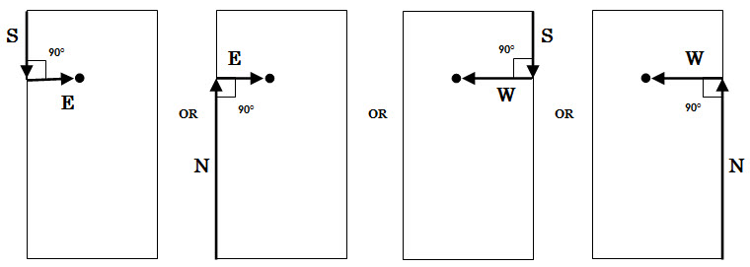
Figure 5 – Diagram illustrating Metes and Bounds (Source: A. Castillo)

Attribute Name | Example 1 | Example 2 | Example 3 | Example 4
Location North South | # of m | # of m | # of m | # of m
North South Flag | S | N | S | N
Location East West | # of m | # of m | # of m | # of m
East West Flag | E | E | W | W

4.1.4 Offshore Tract Naming Convention

Exploration and production of oil and gas on offshore crown lands are managed using a grid system. Petroleum operators are issued exploration licences or production (or storage) leases by the Petroleum Operations Section, MNR. The leases or licences refer to offshore tracts. For example, Dundee Oil and Gas Ltd. can be issued a gas lease on 20-R, where 20 indicates the Block and R indicates the Tract. Further subdivisions of tracts are used for well location purposes only. For example, the well can be in 123-W-3A.

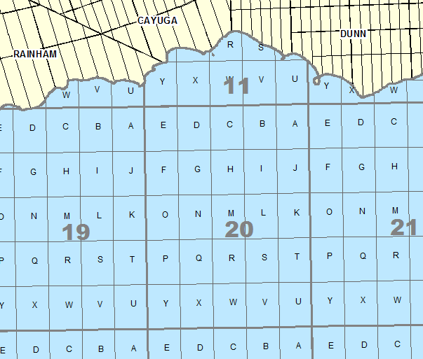
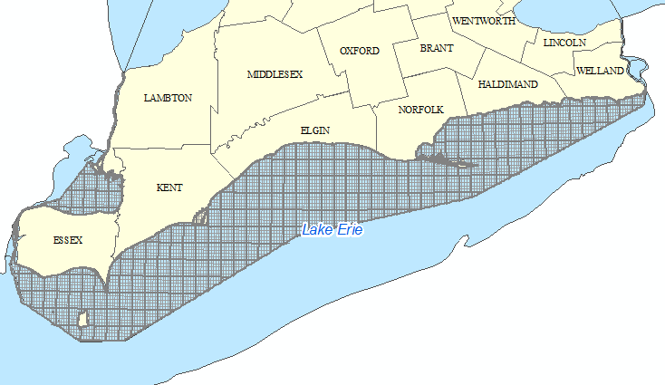

Figure 6 – Map showing Offshore Blocks and Tracts on Lake Erie,
Lake St. Clair and interconnecting waterways (Source: A. Castillo)

This Petroleum Crown Lake Grid data class is available in LIO, see Appendix 1.

The following diagram specifies the method by which Offshore Tracts are named.

In this example, the Block attribute is 123 and the Tract attribute is W-3A.

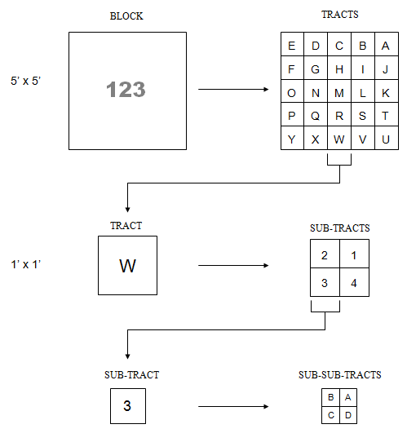
Figure 7 – Diagram illustrating Offshore Blocks and Tracts (Source: A. Castillo)

4.1.5 Well Direction Types

The diagrams below provide a visual interpretation of the types of well directions that occur when drilling:

Vertical Profile:  Indicates whether the well was drilled vertically straight downward. The surface latitude and longitude coordinate is the same as the bottom hole latitude and longitude coordinate. | Directional Profile:  Indicates whether the majority of the well was drilled on an angle. The surface latitude and longitude coordinate differs from the bottom hole latitude and longitude coordinate. | Horizontal Profile:  Indicates whether the bottom portion of the well was drilled horizontally within the target geological formation. The surface latitude and longitude coordinate differs from the bottom hole latitude and longitude coordinate.
 | 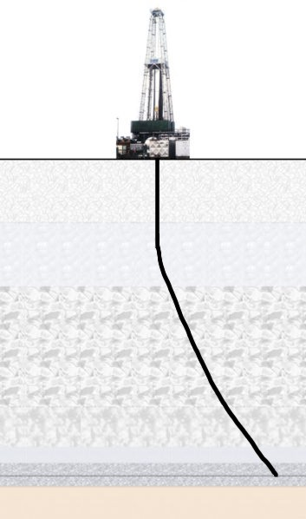 | 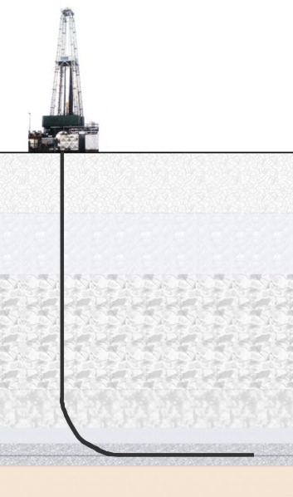

Figure 8 – Profile views of a Vertical Well, a Directional Well and a Horizontal Well (Source: A. Castillo)

An overhead map that illustrates how the well directions may occur in a petroleum field is indicated below.

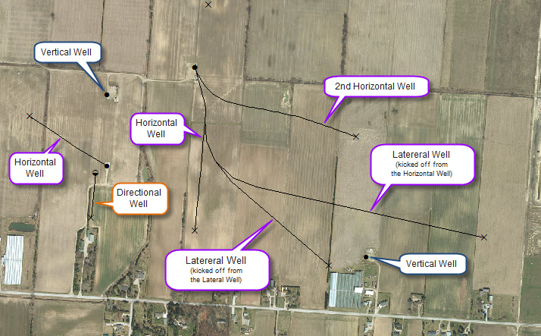

Figure 9 – Overhead Map of a Petroleum Well Field (Source: A. Castillo)

Horizontals wells are drilled first. Lateral wells can be kicked off from existing horizontal wells. Subsequent lateral wells can be kicked off from existing lateral wells.

The spatial points in the Petroleum Well data class are of the surface hole location only. The bottom hole coordinates can be found in the attribute table.

In the map above, the borehole paths (the linear features) and bottom hole points (symbolized by ‘x’) can be acquired by contacting the Spatial Data Specialist of the Petroleum Operations Section at 519-873-4644.

4.1.6 Petroleum Well Symbology Standard

The Map Symbol Code field in the attribute table is used for symbolizing the petroleum well points for map products. An ESRI ArcMap Layer File (.lyr) can be acquired by contacting the Spatial Data Specialist of the Petroleum Operations Section at 519-873-4644.

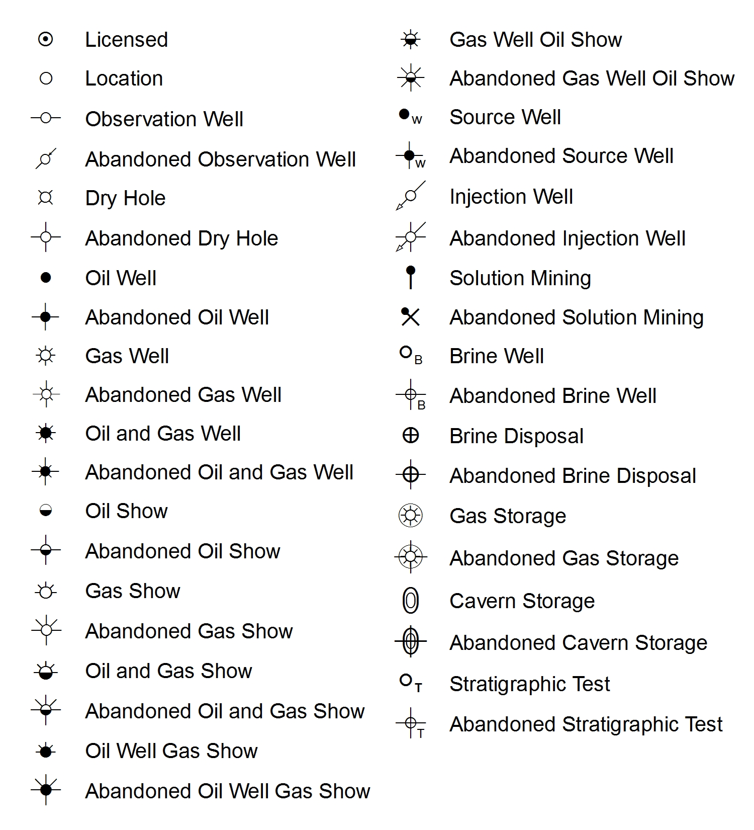
Figure 10 – Legend of the Petroleum Well Symbology standard
(Source: A. Castillo)

4.2 Data Collection Guidelines

The first commercial oil well in North America was drilled in 1858 in Oil Springs, Lambton County, Ontario, Canada. Since then, data collection of petroleum wells in Ontario ranges in varying but improving degrees of quality. Over the decades, legislation has been continually set in place to improve data collecting requirements. Furthermore, emergence of new technology contributed to more accurate and reliable information.
Although, the majority of data in the Petroleum Well data class was derived from historical records, currently, petroleum operators are required to submit forms, reports and well location survey plans to the Petroleum Operations Section. The requirements are outlined in Parts 1 and 13 of the Ontario Oil, Gas, and Salt Resources Provincial Operating Standards.
Improvements to well locations can be obtained from GPS methods or derived from orthophotos within a GIS.
Updates to tabular information can be derived from newly submitted reports, field inspections and in-house modifications.

4.3 Data Maintenance Guidelines
The spatial and tabular data for the Petroleum Well data class is maintained in the Ontario Petroleum Database System (OPDS) by staff of the Petroleum Operations Section, MNR. Information in OPDS is updated on a daily basis.
There are a minimum number of fields that must be populated for each petroleum well record. Records in OPDS that are missing latitude and longitude coordinates or have not been drilled are not included in the Petroleum Well data class. All confidential data have also been excluded.
The data is provided by a View table from OPDS created using SQL scripting. This View is downloaded into the LIO Warehouse on a regular basis (to be defined).
A data life cycle summary diagram can be found in Appendix 3 of this document.

4.4 General Data Access and Viewing
Petroleum Well (PETWELL) data is unclassified (non-sensitive) and available for access and viewing via:
- DDS: Data Class data can be downloaded by subscribers through the LIO Data Distribution System (DDS) from the suite of structured products.
- LIO Mapper: Read-only view of the data class is available to all OPS staff account holders.
- NDD: a distributed cut of the data (geodatabase) is provided to all MNR District servers on a regular basis. This version provides direct access to the data to all District MNR staff. The format was formerly known as the NRVIS Data Distribution (NDD) which will likely be given a new reference acronym in the near future.

Appendix 1: Additional Resources
Links to where additional information about the subject matter can be found online are listed below:
- MNR’s Oil, Gas and Salt Resources web page
- Petroleum Crown Lake Grid data set is available to the public. The metadata record is: Petroleum Crown Lake Grid Metadata Record
- Petroleum Horizontal Well data set is available to the public. The metadata record is: Petroleum Horizontal Well Metadata Record
- Ontario E-Laws: Oil, Gas and Resources Act, Ontario Regulation 245/97, Ontario Regulation 263/02.
- Oil, Gas and Salt Resources of Ontario Provincial Operating Standards.
- LIO Support – LIO Support staff will provide assistance and field any questions about the petroleum well data class, LIO Warehouse and LIO Editor. Email: lio@ontario.ca or Telephone: 705-755-1878
- The Ontario Oil, Gas and Salt Resources Library website.

As this guide contains time-stamped information from the time of authoring, it is recommended that the official LIO Metadata records for the Petroleum Well data class be consulted for up-to-date dataset and business area contact information.

Appendix 2: Responsibilities of a LIO Data Class Information Owner
When (re)designing and implementing a data class in the LIO and/or LIO Editor databases, the Information Owner (IO) will be required to provide input or approvals along the way.
General responsibilities of an Information Owner
- Looks after the health and standards for a particular data set
- Responsibility for the data generally resides with one business area
- Information Owner may delegate day-to-day tasks to other organizations
Information Management Life Cycle
The following steps are often followed when designing a new or re-designing an existing data class: Project identification and management, Data analysis & design, Database implementation, Data compilation, Data loading, Data access, Data maintenance, and Database changes (aka enhancements).
Specific Information Owner Tasks
- a) For an enhancement (small change) provide input to steps 2 to 7
b) For projects (major change or new data set) write or assist the data analyst in the writing of a project justification, charter, plan and close out documentation and approve final documents. Proceed to steps 2 to 7.
- Data Analysis & Design
Provide access to business experts for the analysis process. Approve final design.

3. Database Implementation
- Review and sign off on the LIO physical model (data description document).
- Review the LIO Editor implementation, before rollout, if required.

4. Data Compilation
- Create a data package (i.e. file geodatabase) to be loaded into LIO and LIO editor databases. When applicable, an IO’s business area can also load their data directly using the LIO Editor’s import tools. Proceed to step 5
5. Data loading
- Load the data into the LIO Editor. If the dataset is very large (thousands of features) and/or complex (many child tables), assist the LIO database load team with any file geodatabase load issues.
6. Data Access
- Create and later regularly maintain metadata record via the LRC’s Metadata Management Tool (MMT).
- Test data export from LIO warehouse via the Data Distribution System (DDS).
7. Data maintenance
- Maintain the data, if applicable.
- Ensure data entry standards are met (via user-guides, training).
- Update the MMT record to reflect data’s current status and geographic extent.

8. Database Changes
- For small changes (aka enhancements) – contact LIO support line and submit request. Once approved and assigned to a data analyst, steps 1a to 6 are followed.
- For larger changes requiring new data models – contact your Information Management Coordinator or the GIS Data Services Section Manager. Projects need to be submitted to the GIB Project Management Office for review and approval. Once approved follow step 1b to 6
9. Engaging and Keeping Communications Open with the User Community
This is very important for a data owner to keep in mind when tackling steps 1 to 8. Informing and engaging the user-community of any changes that may impact how they access or use the data will have beneficial spin-off.

Appendix 3: Petroleum Well Data Maintenance
A visual data maintenance and update summary of the Petroleum Well data class.

Appendix 4: Petroleum Well Data Models

Logical Data Model | Physical Data Model

